**1. Summary of Data Collection Methods and Results**

**Data Collection Techniques**

The following methods were employed to gather requirements for the Mobile-Based Attendance Management System:

1. **Surveys**:

- **Purpose**: Collect standardized feedback from a large audience (students, lecturers).

- We used tools like Google Forms with closed-ended (e.g., multiple-choice) and open-ended questions to gain more insight on specific questions

- Some of the questions we asked the students were:

* "How satisfied are you with the current attendance system?"
* "What concerns do you have about mobile-based check-in systems" This question revealed that more than 70% of students are concerned about internet/data

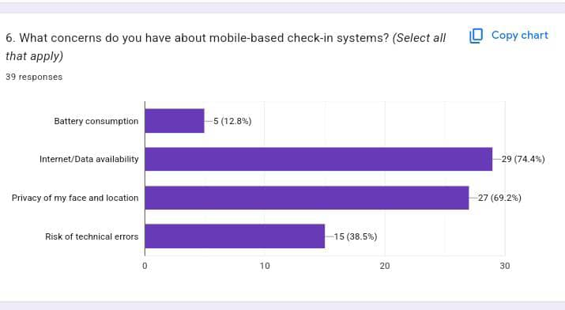

* “What is your opinion about using a Grofencing system for your attendance management?”
* “Which features would you find useful in a student attendance app?”
* “How often have you attended lectures in locations different from the official venue”( To understand the best features to implement for the app)

- **Results**:

- Quantitative: More than 65% of students reported technical issues with existing systems.

- Qualitative: Requests for offline functionality and simplified UI.

2. **Interviews**:

- **Purpose**: Gain in-depth insights from key stakeholders (Lecturers and Administrators).

- **Implementation**:

- We conducted one-on-one sessions with open-ended questions.

- Some of the questions we asked were:

* “What is your biggest challenge with the current attendance method?”
* “What is your opinion on using a facial recognition and Geofencing system to manage students' attendance?”
* “Would you attend a short training to use a smart attendance system?”
* “Would you recommend using a mobile based attendance management system to your school administrative authority”

**Results**:

* 100% of lectures prefer automated system with facial recognition

3. **Brainstorming Sessions**:

- **Purpose**: Generate technical solutions and prioritize features.

- **Implementation**: Collaborative discussions with the development team.

- **Results**:

- Feature prioritization (e.g., GPS check-in and facial recognition as a must-have).

- Identified technical challenges (e.g., ensuring GPS accuracy in indoor environments).

4. **Reverse Engineering**:

- **Purpose**: Analyze competitors’ apps to identify gaps.

- **Implementation**: Reviewed app store reviews and competitor features.

- **Results**:

- Common user complaints: Poor offline support and slow loading times.

- People complained of accuracy issues so, taking this into consideration while building the app

**2. Cleaning and Categorization of Survey and Interview Data**

**Data Cleaning Process**

- **Steps Taken**:

1. **Removal of Noise**:

- Deleted 15% of survey responses due to incompleteness or duplication.

2. **Standardization**:

- Converted inconsistent formats (e.g., "Y/N" → "Yes/No").

3. **Outlier Filtering**:

- Excluded irrelevant responses (e.g., jokes, unrelated feedback).

4. **Qualitative Coding**:

- Tagged open-ended responses into themes (e.g., "Privacy Concerns," "Feature Requests").

**Categorization**

- **Functional Needs**:

- **Check-in Methods**: GPS, facial recognition.

- **Reporting**: Implement customizable attendance reports for lecturers.

- **Non-Functional Needs**:

- **Performance**: It's important to ensure a reasonable response time

- **Accessibility**: Offline mode for areas with poor connectivity.

- **User Behavior Insights**:

- 80% of students use smartphones daily, but 70% face data limitations.

**Conclusion**

The data collection methods provided a robust mix of quantitative and qualitative insights, ensuring alignment with stakeholder needs. Cleaning and categorization transformed raw data into actionable requirements, directly informing the system’s design. This structured approach ensures the project is both user-centric and technically viable.